7. Recv. Pending Transfers

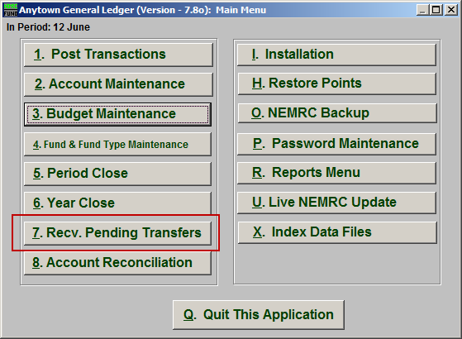
Click on “7. Recv. Pending Transfers” from the Main Menu and the following window will appear:

Recv. Pending Transfers

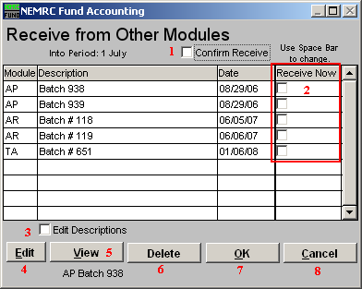
- Confirm Receive: Check this box if you want the system to prompt you during receiving all postings to ensure you are posting the data to the correct period in the General Ledger.

- Receive Now: Check off the box on each line shown in the table for batches you want to receive at this time.

- Edit Descriptions: Click on a line in the table that you would like to change the description of and then click on this button to do so. This is helpful if you want a reminder of when you wish to receive this data during critical times, like year end.

- Edit: Click “Edit” to edit the selected batch.

- View: Click “View” to view the selected batch.

- Delete: Click “Delete” to Delete the selected batch.

- OK: Click “OK” to save changes and return to the previous screen.

- Cancel: Click “Cancel” to cancel and return to the previous screen.

